**Medi-Cal is Under Attack!**

We need your help to tell Congress: Hands Off Our Medi-Cal!

# Congress is trying to cut Medicaid funding by at least $880 billion dollars! This may affect you!

If you have low income, are older, or have a disability, you may be covered by Medicaid. If you have a child with a disability, your child may receive Medicaid-funded services at home or in school. Medicaid is called Medi-Cal in California. It is mostly offered through managed care plans. Medi-Cal offers different programs that each have their own name. **Here is a list of some Medi-Cal funded programs that may be affected by Medicaid cuts:**

* In Home Supportive Services (IHSS)
* Waivers that provide Home and Community-Based Services (HCBS).
  + Home and Community-Based Alternatives (HCBA) Waiver
  + HCBS Waiver for the Developmentally Disabled (HCBS-DD) Waiver
  + Self-Determination Program (SDP)
  + Assisted Living Waiver (ALW)
  + Multipurpose Senior Services Program (MSSP)
  + Medi-Cal Waiver Program (MCWP), previously known as the AIDS Waiver
* Program for All Inclusive Care for the Elderly (PACE)
* Working Disabled Program
* County Mental Health or Behavioral Health Services
* Medi-Cal Access Program (MCAP)
* Medi-Cal Access Infant Program
* California Children Services (CCS)

# What is Medi-Cal? Why is it important?

Medi-Cal is the state of California’s public health insurance program. Medi-Cal covers adults with disabilities, older adults, children, pregnant people, and immigrants who are low income. Almost 40% of Californians are enrolled in Medi-Cal. Medi-Cal insures half of the kids in California. Medi-Cal pays for one in four births in California.

Medi-Cal pays for things like doctors’ appointments, medicine, wheelchairs, walkers, hearing aids, treatments, tests, co-pays, dental care, and surgeries. It pays for personal care attendants that help people with disabilities and older adults live at home, eat, get dressed, and work. It 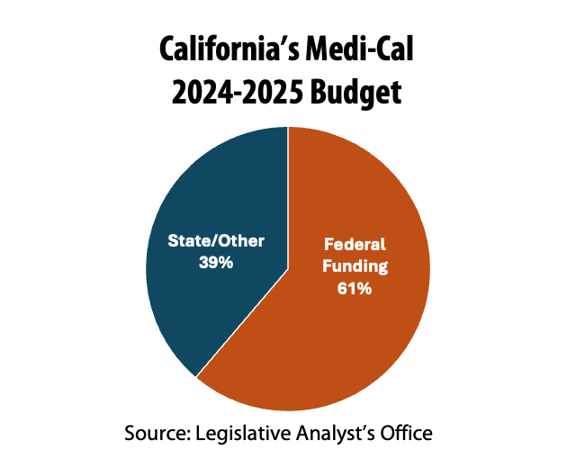pays for nursing homes and long term care for older adults. It funds supported employment and supported housing. It provides services to kids with disabilities in schools.

# How are Medi-Cal and Medicaid connected? What about Medicare?

# Each state has a Medicaid program that is funded by the state and the federal government. In California that program is Medi-Cal.

Medicaid dollars from the federal government make up over half (61%) of California’s Medi-Cal budget. They make up one fifth (21.5%) of the whole state budget.

Medicare is a different public health insurance program that covers people over 65 and people with disabilities. One in five people who have Medicare are also covered by Medicaid because their income is very low. This is called being dually eligible. Nearly 30% of federal Medicaid dollars support people on Medicare. **A threat to Medi-Cal is a threat to Medicare.**

# What is the current threat to Medi-Cal?

Congress is trying to cut Medicaid by at least $880 billion dollars. A Medicaid cut is a decrease in the amount of money that goes to state Medicaid programs like Medi-Cal. Federal cuts to Medicaid will hurt Californians, including people with disabilities, older adults, kids, and other low-income people.

# What can I do to prevent Medi-Cal cuts from happening?

* **Call, send letters, and meet with your members of Congress**: Tell them why Medicaid matters to you and tell them “Hands Off Our Medicaid!”
* **Call, send letters, and meet with your California state representatives**: Tell them why Medi-Cal matters to you and ask them to pressure federal lawmakers to Protect Medicaid!
* **Tell your story about why Medi-Cal matters to you:** Contact DREDF at [media@dredf.org](mailto:media@dredf.org) and share your story.
* **Talk to your community:** Share this flyer. Tell your fellow peers, family, co-workers, and friends why Medi-Cal cuts would hurt Californians, why it should matter to them, and what they can do to help.

**Learn more and take action at:** [**dredf.org/hands-off-our-medicaid/**](https://dredf.org/hands-off-our-medicaid/)[**dredf.org/manos-fuera-de-nuestro-medicaid/**](http://dredf.org/manos-fuera-de-nuestro-medicaid/)